2018~2019第一学期《数据结构》上机实验报告（2017级理科实验班）
序号 | 班级 | 姓名 | 学号 | 完成模块
1 | 理试1701 | 朱帅成 | 41721603 | 类定义 主函数 窗体设计
2 | 理试1701 | 孙嘉彬 | 41721609 | 类定义 主函数 窗体设计
3 | 理试1701 | 芦明铭 | 41721610 | 类定义 主函数 窗体设计
4
指导教师：张志刚 |  |  |  | 助教：张林桐
实验名称：队列实现走迷宫
二叉树的生成、遍历与应用
实验任务：
使用队列找出从入口到出口的最短路径
给定字符串生成二叉树
先序、中序、后序、层次遍历二叉树
给定参数，画分形树
实验目的：
学会并掌握队列的生成与性质，用队列解决实际问题
通过利用栈和队列实现二叉树的各种功能，了解并学习二叉树的储存与递归
运行结果：
用队列走迷宫
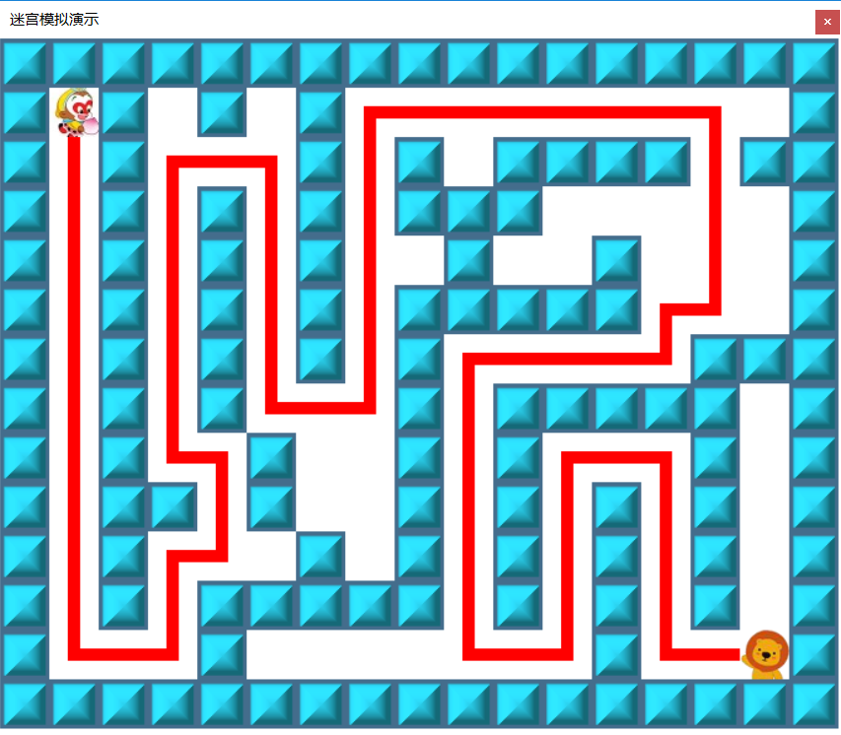

生成二叉树
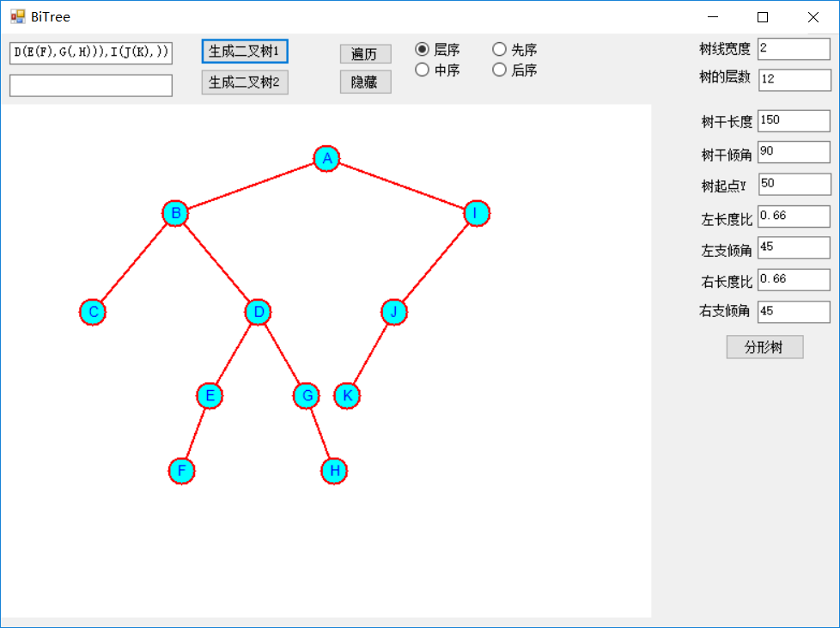

中序遍历
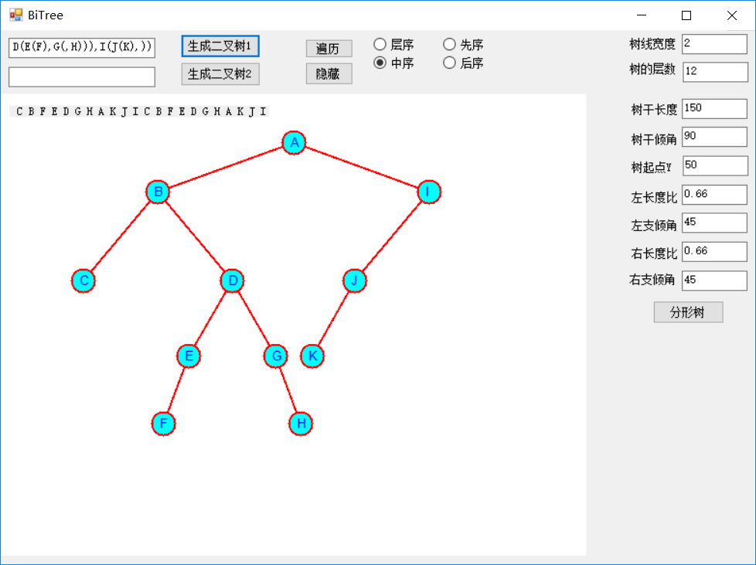

分形
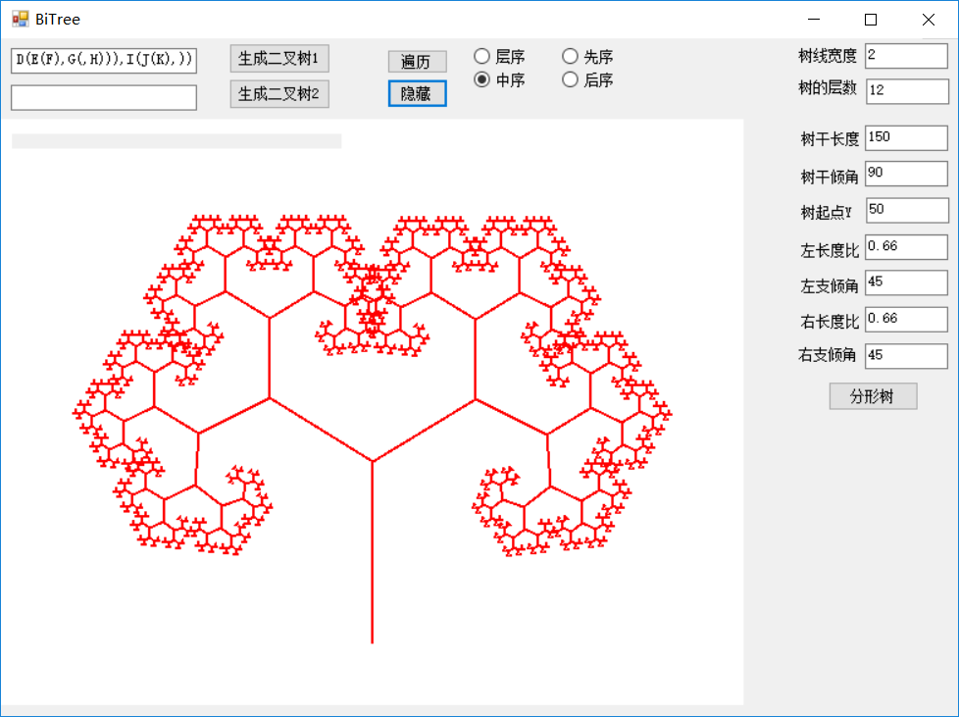
分析讨论：
利用队列走迷宫时，将走过的路径存放在队列中，待到走到终点时，将队列中的函数依次输出。
生成二叉树时，用栈存放字符串，对括号、逗号、字母实施不同操作，并最终存放在链式结构中以实现二叉树。遍历时，利用递归和栈的方法不断缩小到子树以实现遍历。
心得体会：
二叉树是我们接触到的第一个非线性结构，在数据结构中占有重要地位，生活中的许多问题都可以转化成二叉树的模型。二叉树的遍历、搜索都是十分重要的算法，这也给我们之后学习排序与搜索带来新的启发。

2018年 10月 24日
设计方案描述（类设计）：
迷宫类
using System;
using System.Collections.Generic;
using System.Text;
using System.IO;//读取文件所需的

namespace ZZGMaze
{
public struct sqtype//队列的三元组说明,位置和回退下标
{
public int x, y, pre;
}
public struct M //坐标增量表
{
public int x, y;
public M(int mx, int my)
{
x = mx;y = my;
}
}
public class CMaze
{
private int rows, cols;//迷宫矩阵的行列数
private int bi, bj;//迷宫起点坐标
private int ei, ej;//迷宫终点坐标
private int[] elems;
public CQueue<sqtype> sq;
public static M[] move = new M[4] {
new M(-1,0),new M(0,1),new M(1,0),new M(0,-1)
};
//--------------------------------------------------------------------------------
public int Rows { get { return rows; } set { rows = value; } }
public int Cols { get { return cols; } set { cols = value; } }
public int Bi { get { return bi; } set { bi = value; } }
public int Bj { get { return bj; } set { bj = value; } }
public int Ei { get { return ei; } set { ei = value; } }
public int Ej { get { return ej; } set { ej = value; } }

public int Getelems(int row, int col)
{
return elems[row * (cols + 2) + col];
}
public void Setelems(int row, int col,int value)
{
elems[row * (cols + 2) + col] = value;
}
public CQueue<sqtype> MazeQueue()
{
return sq;
}

////////////////////////////////////////////////////////////
public int GetIntData(string strdata,int k,out int outk)
{
int len=strdata.Length;
int ks=k,data;
string str;
while((ks<len)&&((strdata[ks]<'0')||(strdata[ks]>'9')))
ks++;
str = "";
while((ks<len)&&((strdata[ks]>='0')&&(strdata[ks]<='9')))
str=str+strdata[ks++];
if(str!="")
data=Convert.ToInt32(str);
else
data=0;
outk=ks;
return(data);
}
public CMaze(string strmazedata)
{
int i,j,dd,know;
sq = new CQueue<sqtype>();
know = 0;
if (strmazedata == "")
{
rows = cols = 0;
return;
}
rows = GetIntData(strmazedata, know, out know);
cols = GetIntData(strmazedata, know, out know);
bi = GetIntData(strmazedata, know, out know);
bj = GetIntData(strmazedata, know, out know);
ei = GetIntData(strmazedata, know, out know);
ej = GetIntData(strmazedata, know, out know);
elems = new int[(rows + 2) * (cols + 2)];
for (i = 1; i <= rows; i++)
{
for (j = 1; j <= cols; j++)
{
dd = GetIntData(strmazedata, know, out know);
elems[i * (cols + 2) + j] = dd;
}
}
for (i = 0; i <= rows+1; i++)
{
elems[i * (cols + 2) + 0] = 1;
elems[i * (cols + 2) + cols + 1] = 1;
}
for (j = 0; j <= cols+1; j++)
{
elems[0 * (cols + 2) + j] = 1;
elems[(rows + 1) * (cols + 2) + j] = 1;
}
elems[bi * (cols + 2) + bj] = 0;//起点
elems[ei * (cols + 2) + ej] = 0;//终点
}
////////////////////////////////////////////////////////////
public int ShortPath()//最短路径
{
sq = new CQueue<sqtype>();//创建队列
if (Rows == 0 || Cols == 0)
return 0;
sqtype temp = new sqtype();
sqtype temp2 = new sqtype();
temp.x = bi;temp.y = bj; temp.pre = 0; sq.In(temp); Setelems(1, 1, -1);//起点进队
while (!sq.IsEmpty())//队不空时循环
{
temp = sq.Getfront();//取队头
for (int k = 0; k < 4; k++)//查找4个方向
{
int i = temp.x + move[k].x; int j = temp.y + move[k].y;
if (Getelems(i, j) == 0)//路通
{
temp2.x = i;temp2.y = j;temp2.pre = sq.Front()+1;
sq.In(temp2);
Setelems(i, j, -1);
Console.WriteLine(temp2.x + "," + temp2.y+","+temp2.pre);
}
if (i == ei && j == ej)
{
return 1;
}
}
sq.Out();//出队
}
return 0;
}
////////////////////////////////////////////////////////////
public void clear()
{
int i,j;
for(i=1;i<=rows;i++)
{
for (j=1;j<=cols;j++)
{
if (Getelems(i, j) == -1)
Setelems(i, j, 0);
}
}
}
////////////////////////////////////////////////////////////
}
}

栈类
using System;
using System.Collections.Generic;
using System.Text;

namespace ZZGMaze
{
public class CStack<Type>
{
private int top;
private Type[] elems;
private const int Maxsize=100;
//--------------------------------------------------------------------------------
public void MakeEmpty() { top=-1; }//清空
public bool IsEmpty() { return top==-1; }//判栈空
public bool IsFull() { return top==Maxsize-1; }//判栈满
///////////////////////////////////////////////////////////
public CStack()
{
elems=new Type[Maxsize];
top = -1;
}
///////////////////////////////////////////////////////////
public bool Push(ref Type item)//入栈
{
if(!IsFull())
{
elems[++top]=item;
return(true);
}
else
return(false);
}
///////////////////////////////////////////////////////////
public Type Pop()//出栈
{
return elems[top--];
}
///////////////////////////////////////////////////////////
public Type Gettop()
{
return elems[top];
}
///////////////////////////////////////////////////////////
}
}

队列类
using System;
using System.Collections.Generic;
using System.Text;

namespace ZZGMaze
{
public class CQueue<Type>
{
private int front, rear;
private Type[] elems;
private const int Maxsize = 1000;
//--------------------------------------------------------------------------------
public void MakeEmpty() { front=rear=0; }//清空
public bool IsEmpty() { return front==rear; }//判队空
public bool IsFull() { return (rear+1)%Maxsize==front; }//判队满
public int Front() { return front; }
public int Rear() { return rear; }
///////////////////////////////////////////////////////////
public CQueue()
{
elems = new Type[Maxsize];
front = rear = 0;
}
///////////////////////////////////////////////////////////
public bool In(Type item)//入队
{
if (!IsFull())
{
rear = (rear + 1) % Maxsize;
elems[rear] = item;
return (true);
}
else
return (false);
}
///////////////////////////////////////////////////////////
public Type Out()//出队
{
front = (front + 1) % Maxsize;
return elems[front];
}
///////////////////////////////////////////////////////////
public Type Getfront()
{
return elems[(front + 1) % Maxsize];
}
///////////////////////////////////////////////////////////
public Type Getdata(int k)
{
return elems[k];
}
///////////////////////////////////////////////////////////
}
}

二叉树类
using System;
using System.Collections.Generic;
using System.Text;
using System.Drawing;
using System.Windows.Forms;
using System.Threading;

namespace tree
{
public interface ICStack<Type>//接口
{
bool IsEmpty();//判栈空
bool IsFull();//判栈满
void MakeEmpty();//清空
bool Push(Type item);//入栈
Type Pop();//出栈
Type Gettop();//取栈顶
string GetStackALLDate(string sname);
}

class CStacknode<Type>//链栈结点类
{
private Type data;
private CStacknode<Type> next;
//--------------------------------------------------------------------------------
public CStacknode()
{
next = null;
}
public CStacknode(Type data)
{
this.data = data;
next = null;
}
public CStacknode(Type data, CStacknode<Type> next)
{
this.data = data;
this.next = next;
}
public Type Data
{
get { return data; }
set { data = value; }
}
public CStacknode<Type> Next
{
get { return next; }
set { next = value; }
}
}
class CLinkStack<Type> : ICStack<Type>
{
private CStacknode<Type> top;
//--------------------------------------------------------------------------------
public void MakeEmpty() { top = null; }//清空
public bool IsEmpty() { return top == null; }//判栈空
public bool IsFull() { return false; }//判栈满

public CLinkStack()
{
top = null;
}
public bool Push(Type item)//入栈
{
top = new CStacknode<Type>(item, top);
return (true);
}
public Type Pop()//出栈
{
Type dt = top.Data;
top = top.Next;
return dt;
}
public Type Gettop()//取栈顶
{
if (top == null)
return default(Type);
else
return top.Data;
}
public string GetStackALLDate(string sname)
{
string str = " 】";
if (IsEmpty()) str = sname + " stack is null";
CStacknode<Type> p = top;
while (p != null)
{
str = p.Data + " " + str;
p = p.Next;
}
str = "【 " + str + "\r\n";
str = str + "---------------------------------------" + "\r\n";
return str;
}
}

public class CSeqStack<Type> : ICStack<Type>
{
private int top;
private Type[] elems;
private int Maxsize = 100;
//--------------------------------------------------------------------------------
public void MakeEmpty() { top = -1; }//清空
public bool IsEmpty() { return top == -1; }//判栈空
public bool IsFull() { return top == Maxsize - 1; }//判栈满
///////////////////////////////////////////////////////////
public Type this[int index]
{
get { return elems[index]; }
set { elems[index] = value; }
}
public int Top
{
get { return top; }
}

public CSeqStack()
{
elems = new Type[Maxsize];
top = -1;
}
public CSeqStack(int max)
{
Maxsize = max;
elems = new Type[Maxsize];
top = -1;
}
///////////////////////////////////////////////////////////
public bool Push(Type item)//入栈
{
if (!IsFull())
{
elems[++top] = item;
return (true);
}
else
return (false);
}
///////////////////////////////////////////////////////////
public Type Pop()//出栈
{
if (!IsEmpty())
return elems[top--];
else
return elems[0];
}
///////////////////////////////////////////////////////////
public Type Gettop()//取栈顶
{
if (!IsEmpty())
return elems[top];
else
return elems[0];
}
public string GetStackALLDate(string sname)
{
string str = "";
if (IsEmpty()) str = sname + " stack is null";
for (int i = 0; i <= top; i++)
{
str = str + " " + elems[i].ToString() + " ";
}
str = str + "\r\n";
//str = str + "--------------------------------------------------" + "\r\n";
return str;
}
///////////////////////////////////////////////////////////
}
public class CQueue<Type>
{
private int front, rear;
private Type[] elems;
private const int Maxsize = 1000;
//--------------------------------------------------------------------------------
public void MakeEmpty() { front = rear = 0; }//清空
public bool IsEmpty() { return front == rear; }//判队空
public bool IsFull() { return (rear + 1) % Maxsize == front; }//判队满
public int Front() { return front; }
public int Rear() { return rear; }
///////////////////////////////////////////////////////////
public CQueue()
{
elems = new Type[Maxsize];
front = rear = 0;
}
///////////////////////////////////////////////////////////
public bool In(Type item)//入队
{
if (!IsFull())
{
rear = (rear + 1) % Maxsize;
elems[rear] = item;
return (true);
}
else
return (false);
}
///////////////////////////////////////////////////////////
public Type Out()//出队
{
front = (front + 1) % Maxsize;
return elems[front];
}
///////////////////////////////////////////////////////////
public Type Getfront()
{
return elems[(front + 1) % Maxsize];
}
///////////////////////////////////////////////////////////
public Type Getdata(int k)
{
return elems[k];
}
///////////////////////////////////////////////////////////
}
public class drawbtreetype<Type>
{
public CBinaryTreenode<Type> pbtnode;
public double px, py;
public int level;
}; //画二叉树图时的辅助表
public class help<Type>
{
public int t1b, t2b, tln;//先序中开始位置,中序中开始位置,树长
public CBinaryTreenode<Type> adr;
}; //由先序序列,中序序列生成二叉树的帮助表
public class CBinaryTreenode<Type>
{
public Type data;
public bool isStepped = false;
public CBinaryTreenode<Type> lchild, rchild;
public CBinaryTreenode()
{
lchild = rchild = null;
}
public CBinaryTreenode(Type item)
{
data = item;
lchild = rchild = null;
}
public CBinaryTreenode(Type item, CBinaryTreenode<Type> lc, CBinaryTreenode<Type> rc)
{
data = item;
lchild = lc; rchild = rc;
}

}
class CBinaryTree
{
public CBinaryTreenode<char> treeroot;
public void CreateBinTreestr(string bintreestr)//根据字符串生成二叉树表
{
if (treeroot != null)
treeroot = null;
string strt = "1234567890+-*/";
char ch, chlr = ' ';
CLinkStack<CBinaryTreenode<char>> mystack = new CLinkStack<CBinaryTreenode<char>>();
CBinaryTreenode<char> stp, stpnew;//存放栈顶的返回值
stpnew = null;
int n = bintreestr.Length;
for (int i = 0; i < n; i++)
{
ch = bintreestr[i];
if (((ch >= 'A') && (ch <= 'Z')) || ((ch >= 'a') && (ch <= 'z')) || (strt.IndexOf(ch) >= 0))
{
//取栈顶
stp = mystack.Gettop();
//创建节点并于栈顶链接
stpnew = new CBinaryTreenode<char>(ch);
if (stp == null)
treeroot = stpnew;
else
{
if (chlr == 'l')
stp.lchild = stpnew;
else
stp.rchild = stpnew;
}
}
else if (ch == '(')
{
chlr = 'l';//设置左右
mystack.Push(stpnew);//当前点入栈
}
else if (ch == ',')
chlr = 'r';//设置左右
else if (ch == ')')
mystack.Pop();//出栈
}
}
public void Traversal(int k, out string m_strout)
{
m_strout = "";

if (k == 0)
{
CQueue<CBinaryTreenode<char>> qtree = new CQueue<CBinaryTreenode<char>>();
CBinaryTreenode<char> p;
qtree.In(treeroot);
if(treeroot!=null)
while (!qtree.IsEmpty())
{
p = qtree.Out();
if (p.lchild != null)
qtree.In(p.lchild);
if (p.rchild != null)
qtree.In(p.rchild);
m_strout += " " + p.data;
}

}
else
{
CLinkStack<CBinaryTreenode<char>> stree = new CLinkStack<CBinaryTreenode<char>>();
CLinkStack<int> sno = new CLinkStack<int>();
CBinaryTreenode<char> p;
stree.Push(treeroot);
int no;
if (treeroot != null)
{ stree.Push(treeroot); sno.Push(1);sno.Push(1); }
else
{
m_strout = "空树!\r\n";
return;
}
while (!stree.IsEmpty())
{
no = sno.Pop();
p = stree.Gettop();
if (p == null)
{
stree.Pop();
continue;
}
if (no == 1)
{
sno.Push(2);
stree.Push(p.lchild);
sno.Push(1);
if (k == 1)
m_strout += " " + p.data.ToString();
}
else if (no == 2)
{
sno.Push(3);
stree.Push(p.rchild); sno.Push(1);
if (k == 2)
m_strout += " " + p.data.ToString();
}
else if (no == 3)
{
stree.Pop();
if (k == 3)
m_strout += " " + p.data.ToString();
}
}
}
}

public void DrawBTree(PictureBox pb_bstree)
{
CLinkStack<drawbtreetype<char>> stree = new CLinkStack<drawbtreetype<char>>();
drawbtreetype<char> sp, spt;
CBinaryTreenode<char> pbtnode, pbtnodenow;
if (treeroot == null)
return;
Graphics myg;
int xmin = 0;
int ymin = 0;
int xmax, ymax;

myg = pb_bstree.CreateGraphics();
xmax = pb_bstree.Width;
ymax = pb_bstree.Height;
//设置显示颜色
Color bkColor0;
Brush bkBrush0;
Brush bkbrush = new SolidBrush(Color.White);//背景色
bkColor0 = Color.FromArgb(255, 0, 255, 255);
bkBrush0 = new SolidBrush(bkColor0);
Pen pen1 = new Pen(Color.Red, 2);
//画背景
myg.FillRectangle(bkbrush, xmin, ymin, xmax - xmin, ymax - ymin);
string str;
Font font = new Font("Arial", 10);
SolidBrush b1 = new SolidBrush(Color.Blue);
StringFormat sf1 = new StringFormat();

//画图数据初始化
double xx = xmax / 2;
double yy = ymax - 50;
int level = 1;
double xnow;
double ynow;
double alpha;

double len = 150;
double lenbl = 0.8;
double dw = 0;
//画树根中心点
spt = new drawbtreetype<char>();
spt.pbtnode = treeroot;
spt.px = xx;
spt.py = yy;
spt.level = level;
stree.Push(spt);//树根入栈
myg.FillEllipse(bkBrush0, (int)(xx - 12), (int)(ymax - yy - 12), 24, 24);
myg.DrawEllipse(pen1, (int)(xx - 12), (int)(ymax - yy - 12), 24, 24);
str = "" + treeroot.data;
myg.DrawString(str, font, b1, (int)(xx - 5), (int)(ymax - yy - 8), sf1);
while (!stree.IsEmpty())
{
sp = stree.Pop();
pbtnode = sp.pbtnode;
xx = sp.px;
yy = sp.py;
level = sp.level;
//设置比例
if (level == 0)
{ lenbl = 0; dw = 0; }
else if (level == 1)
{ lenbl = 1; dw = 70; }
else if (level == 2)
{ lenbl = 0.8; dw = 40; }
else if (level == 3)
{ lenbl = 0.6; dw = 30; }
else if (level == 4)
{ lenbl = 0.5; dw = 20; }
else if (level == 5)
{ lenbl = 0.4; dw = 15; }
else
{ lenbl = 0.3; dw = 15; }
pbtnodenow = pbtnode.lchild;
if (pbtnodenow != null)
{
//设置转角
alpha = -90 - dw;
//求新点坐标
xnow = xx + len * lenbl * Math.Cos(alpha * 3.14 / 180.0);
ynow = yy + len * lenbl * Math.Sin(alpha * 3.14 / 180.0);
//画线
myg.DrawLine(pen1, (int)xx, (int)(ymax - yy), (int)xnow, (int)(ymax - ynow));
//画中心点
myg.FillEllipse(bkBrush0, (int)(xx - 12), (int)(ymax - yy - 12), 24, 24);
myg.DrawEllipse(pen1, (int)(xx - 12), (int)(ymax - yy - 12), 24, 24);
str = "" + pbtnode.data;
myg.DrawString(str, font, b1, (int)(xx - 5), (int)(ymax - yy - 8), sf1);
myg.FillEllipse(bkBrush0, (int)(xnow - 12), (int)(ymax - ynow - 12), 24, 24);
myg.DrawEllipse(pen1, (int)(xnow - 12), (int)(ymax - ynow - 12), 24, 24);
str = "" + pbtnodenow.data;
myg.DrawString(str, font, b1, (int)(xnow - 5), (int)(ymax - ynow - 8), sf1);

//左孩子结点入栈
spt = new drawbtreetype<char>();
spt.pbtnode = pbtnodenow;
spt.px = xnow;
spt.py = ynow;
spt.level = level + 1;
stree.Push(spt);
}
Thread.Sleep(100);
pbtnodenow = pbtnode.rchild;
if (pbtnodenow != null)
{
//设置转角
alpha = -90 + dw;
//求新点坐标
xnow = xx + len * lenbl * Math.Cos(alpha * 3.14 / 180.0);
ynow = yy + len * lenbl * Math.Sin(alpha * 3.14 / 180.0);
//画线
myg.DrawLine(pen1, (int)xx, (int)(ymax - yy), (int)xnow, (int)(ymax - ynow));
//画中心点
myg.FillEllipse(bkBrush0, (int)(xx - 12), (int)(ymax - yy - 12), 24, 24);
myg.DrawEllipse(pen1, (int)(xx - 12), (int)(ymax - yy - 12), 24, 24);
str = "" + pbtnode.data;
myg.DrawString(str, font, b1, (int)(xx - 5), (int)(ymax - yy - 8), sf1);
myg.FillEllipse(bkBrush0, (int)(xnow - 12), (int)(ymax - ynow - 12), 24, 24);
myg.DrawEllipse(pen1, (int)(xnow - 12), (int)(ymax - ynow - 12), 24, 24);
str = "" + pbtnodenow.data;
myg.DrawString(str, font, b1, (int)(xnow - 5), (int)(ymax - ynow - 8), sf1);

//右孩子结点入栈
spt = new drawbtreetype<char>();
spt.pbtnode = pbtnodenow;
spt.px = xnow;
spt.py = ynow;
spt.level = level + 1;
stree.Push(spt);
Thread.Sleep(100);
}
}
}
public void StoBT(string t1, string t2)
{
//由先序序列,中序序列生成二叉树
if (treeroot != null)
treeroot = null;
int len = t1.Length;
if (len <= 0) return;
int i;
int t2r, lln, rln;//中序的根,左子树长,右子树长
CQueue<help<char>> sq = new CQueue<help<char>>();
help<char> sp = new help<char>();
sp.t1b = sp.t2b = 1; sp.tln = len;
sp.adr = new CBinaryTreenode<char>(t1[1 - 1]);
treeroot = sp.adr;
sq.In(sp);
while (!sq.IsEmpty())
{
i = 1;
sp = sq.Out();
while (t2[i - 1] != t1[sp.t1b - 1])
i++; //在中序中找根
t2r = i;
lln = t2r - sp.t2b; //左子树长
rln = sp.tln - lln - 1; //右子树长
if (lln > 0) //左子树不空
{
help<char> sr = new help<char>();
sr.t1b = sp.t1b + 1; //左子树在先序中的开始位置
sr.t2b = sp.t2b; //左子树在中序中的开始位置
sr.tln = lln;
sr.adr = new CBinaryTreenode<char>(t1[sr.t1b - 1]);//左子树的根
sp.adr.lchild = sr.adr;
sq.In(sr);
}
if (rln > 0) //右子树不空
{
help<char> sr = new help<char>();
sr.t1b = sp.t1b + lln + 1; //右子树在先序中的开始位置
sr.t2b = t2r + 1; //右子树在中序中的开始位置
sr.tln = rln;
sr.adr = new CBinaryTreenode<char>(t1[sr.t1b - 1]);//右子树的根
sp.adr.rchild = sr.adr;
sq.In(sr);
}
}
return;
}

}
}

主要程序清单：
迷宫
using System;
using System.Collections.Generic;
using System.ComponentModel;
using System.Data;
using System.Drawing;
using System.Text;
using System.Windows.Forms;

namespace ZZGMaze
{
public partial class Form_Maze : Form
{

int minx=0,maxx = 0;
int miny=0,maxy = 0;
int dx, dy;

void initdraw()
{
dx = 0;
minx = dx;
maxx = Convert.ToInt32(Math.Floor((this.Width - 2*dx) / 10.0) * 10);
dy = 0;
miny = dy;
maxy = Convert.ToInt32(Math.Floor((this.Height - 2*dy) / 10.0) * 10);
Graphics myg = this.CreateGraphics();
Brush b0 = new SolidBrush(Color.White);
//myg.Clear(Color.FromArgb(255,224,224,224));
myg.FillRectangle(b0, minx, miny, maxx - minx, maxy - miny);
}

public Form_Maze()
{
InitializeComponent();
}

private void Form_Maze_Load(object sender, EventArgs e)
{
}

private void Form_Maze_Paint(object sender, PaintEventArgs e)
{
initdraw();
}
}
}

二叉树
using System;
using System.Collections.Generic;
using System.ComponentModel;
using System.Data;
using System.Drawing;
using System.Linq;
using System.Text;
using System.Threading.Tasks;
using System.Windows.Forms;

namespace tree
{
public partial class Form1 : Form
{
bool num1=true;
int m_penwidth;
int m_level;
double m_langel;
double m_rangel;
double m_llen;
double m_rlen;
double m_length;
double m_angel;
int m_zby;
Graphics myg;
CBinaryTree tree = new CBinaryTree();

public string strout = "";

private void renew()
{
m_penwidth = Convert.ToInt32(width.Text);
m_level = Convert.ToInt32(cengshu.Text);
m_langel = Convert.ToDouble(zzqj.Text);
m_rangel = Convert.ToDouble(yzqj.Text);
m_llen = Convert.ToDouble(zcdb.Text);
m_rlen = Convert.ToDouble(ycdb.Text);
m_angel = Convert.ToDouble(sgqj.Text);
m_length = Convert.ToDouble(sgcd.Text);
m_zby = Convert.ToInt32(sqdy.Text);
int xmin = 0;
int ymin = 0;
int xmax, ymax;

myg = pictureBox1.CreateGraphics();
xmax = pictureBox1.Width;
ymax = pictureBox1.Height;
//设置显示颜色
Color bkColor0;
Brush bkBrush0;
Brush bkbrush = new SolidBrush(Color.White);//背景色
bkColor0 = Color.FromArgb(255, 0, 255, 255);
bkBrush0 = new SolidBrush(bkColor0);
Pen pen1 = new Pen(Color.Red, 2);
//画背景
myg.FillRectangle(bkbrush, xmin, ymin, xmax - xmin, ymax - ymin);

}
private void DrawTree1(int n, double len, double arg, int x, int y)
{
Pen pen1 = null;
pen1 = new Pen(Color.FromArgb(255, 255, 0, 0), m_penwidth);
int xx, yy;
xx = (int)(len * Math.Cos(arg)); yy = (int)(len * Math.Sin(arg));
Point p1 = new Point(x, pictureBox1.Height - y);
Point p2 = new Point(x + xx, pictureBox1.Height - (y + yy));
myg.DrawLine(pen1, p1, p2);
double lt = m_langel;
double rt = m_rangel;
if ((n < m_level)&& (len >= 1))
{
DrawTree1(n + 1, len * m_llen, arg + lt, x + xx, y + yy);
DrawTree1(n + 1, len * m_rlen, arg - rt, x + xx, y + yy);

}

}

public Form1()
{
InitializeComponent();
}

private void pictureBox1_Click(object sender, EventArgs e)
{

}

private void button1_Click(object sender, EventArgs e)
{
tree.CreateBinTreestr(textBox1.Text);
tree.DrawBTree(pictureBox1);
}

private void button2_Click(object sender, EventArgs e)
{
if (num1)
{
textBox1.Text = "ABHFDECKG";
textBox2.Text = "HBDFAEKCG";
num1 = false;
}
tree.StoBT(textBox1.Text, textBox2.Text);
tree.DrawBTree(pictureBox1);
}

private void panel3_Paint(object sender, PaintEventArgs e)
{

}

private void label2_Click(object sender, EventArgs e)
{

}

private void label4_Click(object sender, EventArgs e)
{

}

private void label7_Click(object sender, EventArgs e)
{

}

private void button3_Click(object sender, EventArgs e)
{
renew();
DrawTree1(1, m_length, m_angel * 3.14 / 180.0, pictureBox1.Width / 2, m_zby);

}

private void button4_Click(object sender, EventArgs e)
{
if(radioButton1.Checked == true)
{
string strout = "";
tree.Traversal(0, out strout);
label10.Text = strout;
}
else if (radioButton2.Checked == true)
{
string strout = "";
tree.Traversal(1, out strout);
label10.Text = strout;
}
else if (radioButton3.Checked == true)
{
string strout = "";
tree.Traversal(2, out strout);
label10.Text = strout;
}
else
{
string strout = "";
tree.Traversal(3, out strout);
label10.Text = strout;
}

label10.Visible = true;
}

private void button5_Click(object sender, EventArgs e)
{
label10.Visible = false;
}
}
}

